**Exercise 1: Inventory Management System**

**Output:**

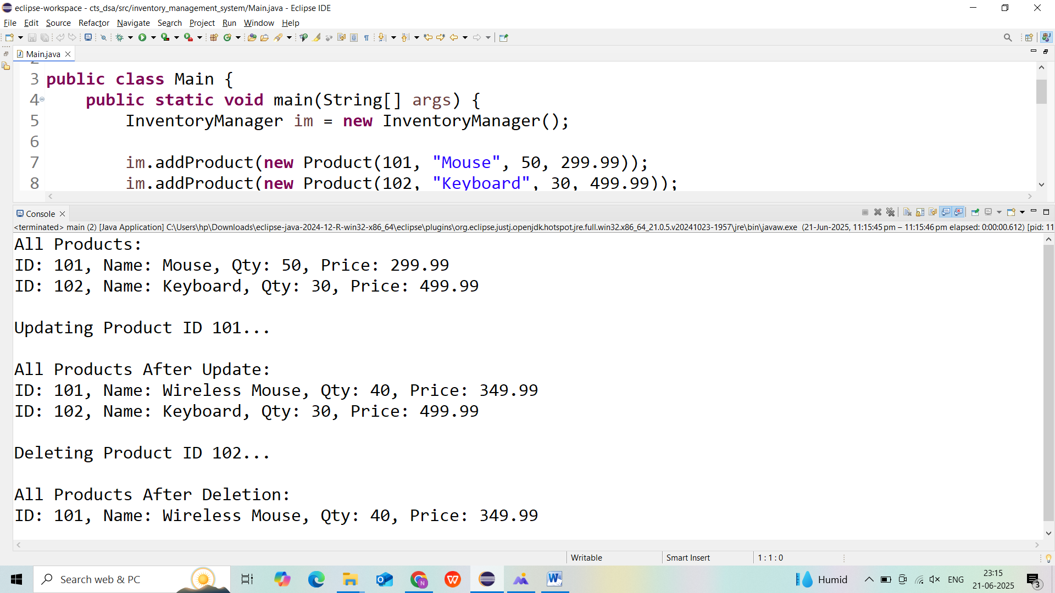

**Exercise 3: Sorting Customer Orders**

**Output:**

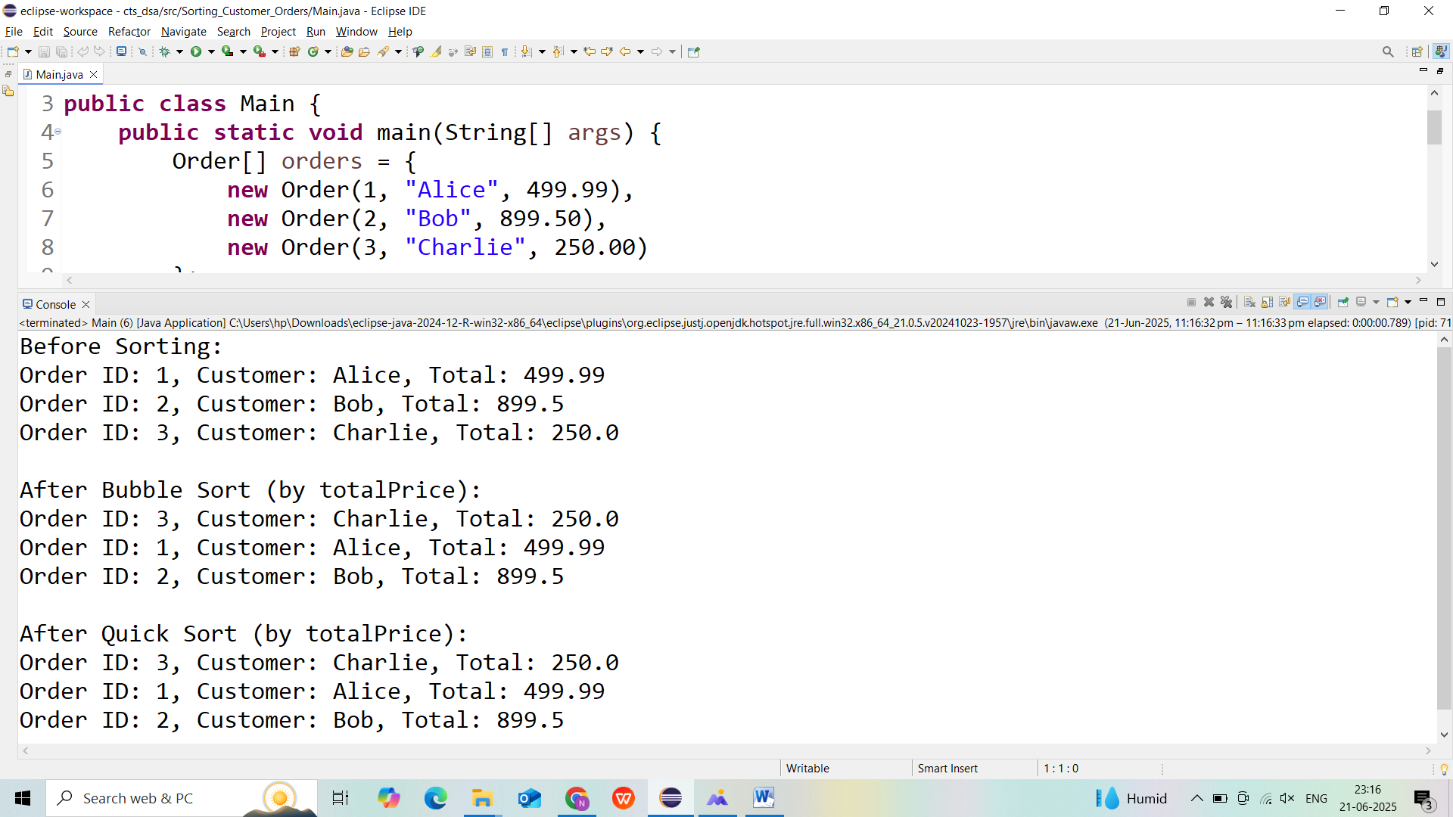

**Exercise 4: Employee Management System**

**Output:**

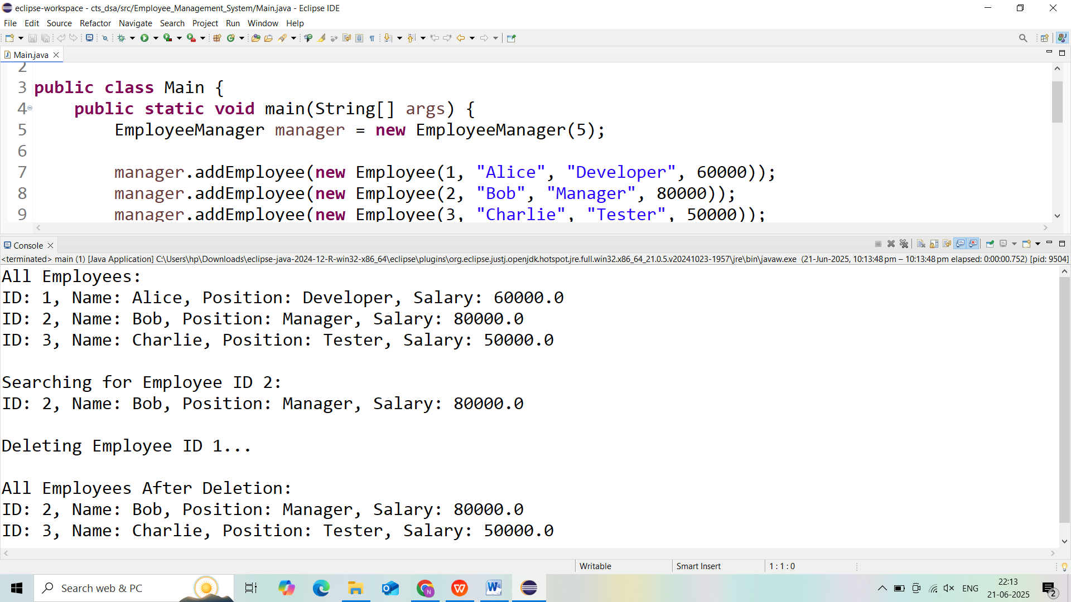

**Exercise 5: Task Management System**

**Output:**

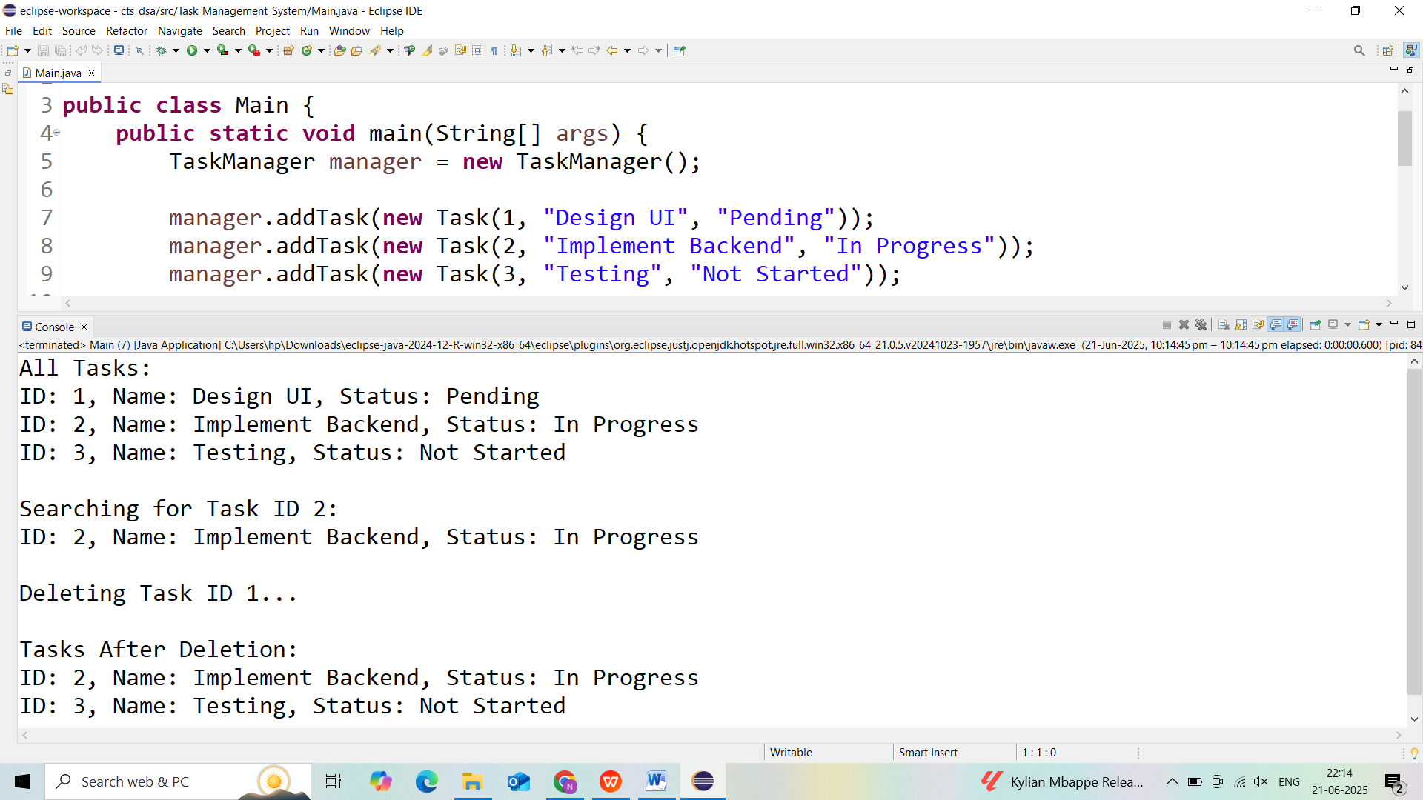

**Exercise 6: Library Management System**

**Output:**

